1.) Install the package (<https://pub.dev/packages/firebase_messaging/install>)

2.) Go to Firebase console ([https://console.firebase.google.com/](https://console.firebase.google.com/u/0/?pli=1)), create a json file and add this json file to android->src->..

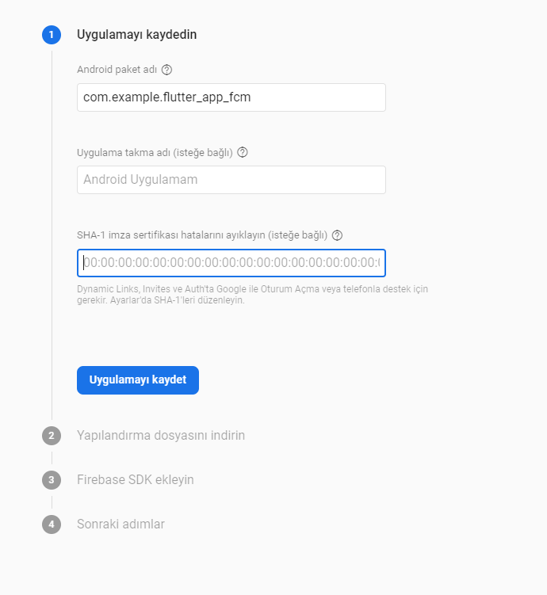

3.) Add the classpath to the [project]/android/build.gradle file.

classpath 'com.android.tools.build:gradle:3.5.3'  
classpath 'com.google.gms:google-services:4.3.2'

4.) Add the apply plugin to the [project]/android/app/build.gradle file.

*// ADD THIS AT THE BOTTOM*

apply plugin: 'com.google.gms.google-services'

Until this time this is okey when your app is open, but when the app is close if you want to see notification, we need to do some more steps.

5.) add the below code to the android/app/src/main/AndroidManifest.xml

<intent-filter> <action android:name="FLUTTER_NOTIFICATION_CLICK" /> <category android:name="android.intent.category.DEFAULT" /> </intent-filter>

6.) add to <app-name>/android/app/build.gradle.

implementation 'com.google.firebase:firebase-messaging:<**latest_version**>'

**Chech the latest version of the firebase-messaging (**[**https://firebase.google.com/support/release-notes/android#java**](https://firebase.google.com/support/release-notes/android#java)**)**

**7.) Copy the application ktx code to kotlin (Warning)**



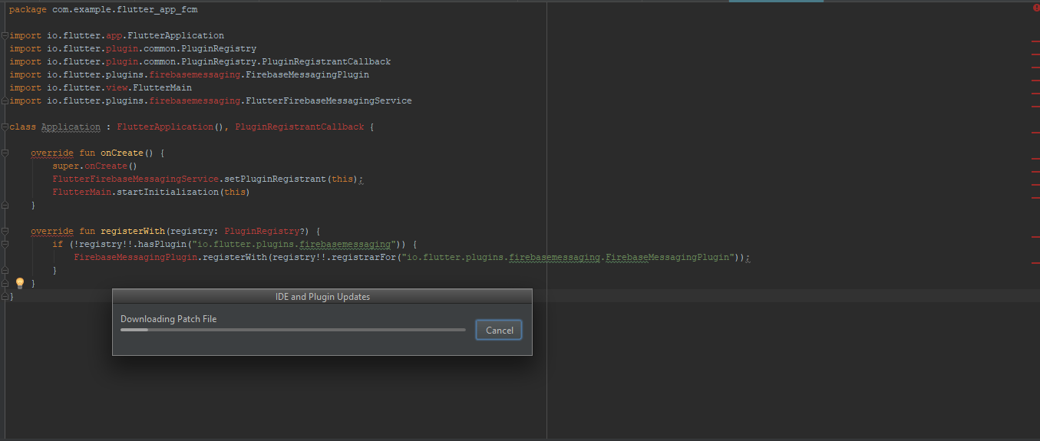

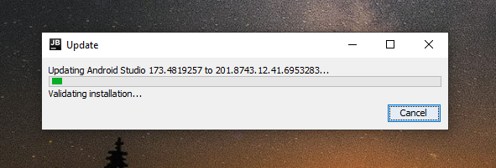

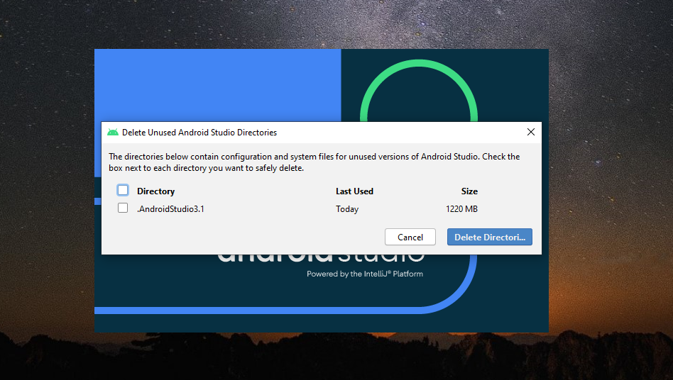

8.) and also add <app-name>/android/app/src/main/androidma...

<application android:name=".Application" ...>

9.) And run the Samet hoca code.

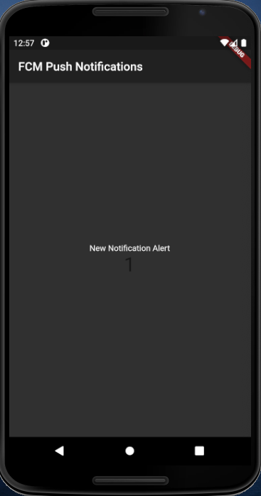

10.)

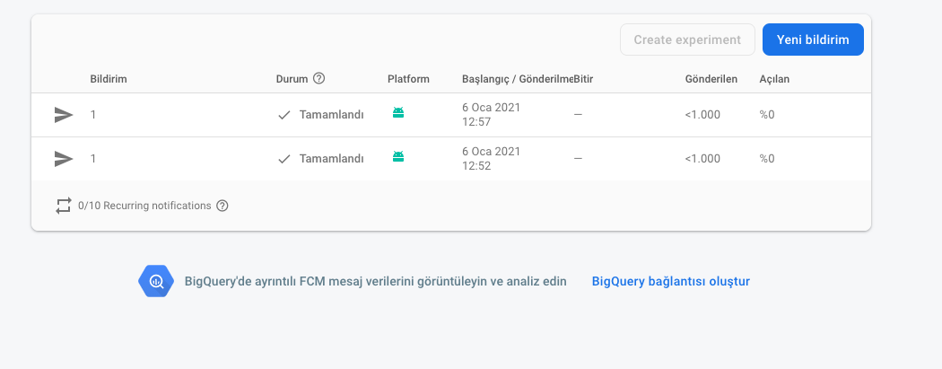

11.) 

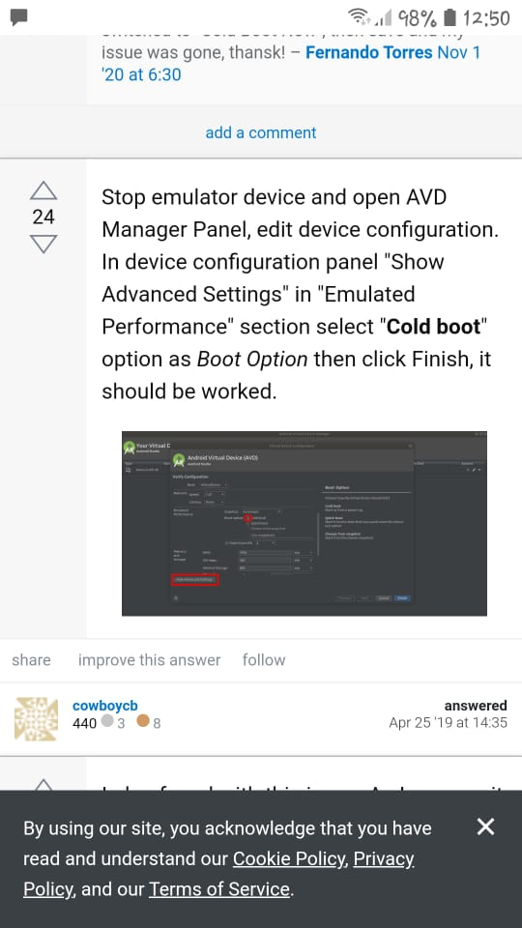

Homework: Please use your own computer, and as I said in the lab class, you need to upload canvas a single PNG file that contains Firebase Cloud Messaging, Emulator, and Android Studio (You can find an example below). I need to see on the screen that you have done this homework on your computer; otherwise, you can not get any point on this homework.

The due date is 13.01.2020.

Not: If you are using your own Mobile phone, you can use Vysor (https://www.vysor.io/). You need to install it on your computer and your phone and connect via USB cable.

